# 8.Technical Description

## Module 1:

### Model 1: Image Captioning using BLIP (Bootstrapped Language–Image Pretraining)

**Technical Description**

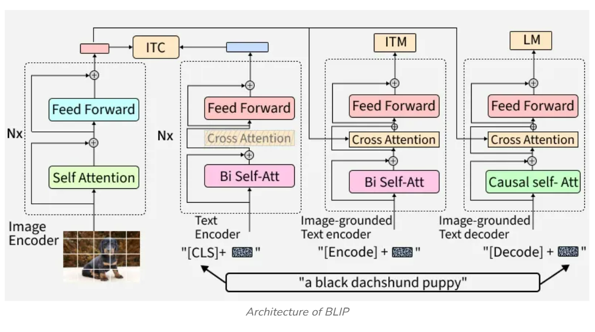

**FIG: BLIP (Bootstrapped Language–Image Pretraining)**

**Introduction**

Image captioning is a multimodal learning task that aims to generate a natural language description for a given image. It lies at the intersection of computer vision and natural language processing (NLP).

This module implements an image captioning backend service using FastAPI and the BLIP (Bootstrapped Language–Image Pretraining) model developed by Salesforce. The system accepts an image as input and generates a semantically meaningful caption describing the visual content.

**System Overview**

The system follows a server-based inference architecture:

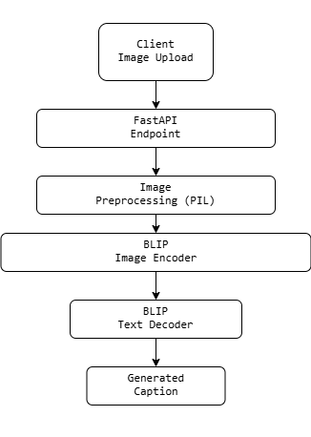

**FIG: SYSTEM ARCHITECTURE**

The BLIP model is loaded once at application startup to ensure low-latency inference.

**BLIP Model Overview**

BLIP stands for Bootstrapped Language–Image Pretraining. It is a vision–language model (VLM) designed to learn joint representations of images and text.

BLIP is capable of:

1.Image Captioning

2.Image–Text Retrieval

3.Visual Question Answering (VQA)

In this module, BLIP is used in image-to-text generation mode.

**Model Architecture**

BLIP consists of three major components:

Image → Vision Encoder → Multimodal Fusion → Text Decoder → Caption

**Vision Encoder**

The vision encoder is a Vision Transformer (ViT) that converts an image into a sequence of visual embeddings.

**Multimodal Transformer**

A transformer-based fusion module aligns visual embeddings with textual representations.

**Text Decoder**

A language model decoder generates captions autoregressively, token by token.

**Image Encoding (Vision Transformer)**

**Image Patch Embedding**

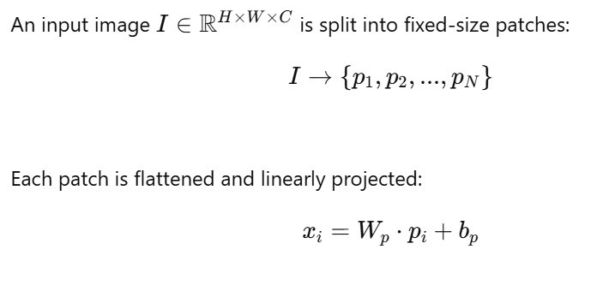

Positional embeddings are added to retain spatial information.

**Self-Attention Mechanism**

The Vision Transformer and language decoder both rely on scaled dot-product attention:

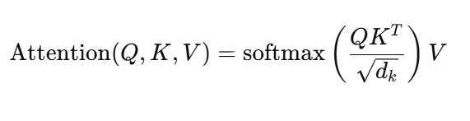

Where:

(Q) = Query matrix

(K) = Key matrix

(V) = Value matrix

(d\_k) = Key dimension

This allows the model to focus on relevant regions of the image while generating words.

**Multimodal Alignment**

BLIP aligns image and text embeddings into a shared latent space:

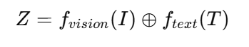

This alignment enables the model to associate visual features with linguistic concepts such as objects, actions, and attributes.

**Text Generation Process**

The caption is generated autoregressively:

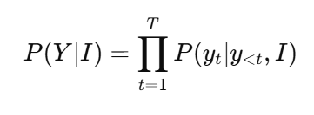

At each time step:

1.Previous tokens are fed into the decoder

2.Cross-attention attends to image embeddings

3.Next token probability is computed

**Decoder Output and Softmax**

The decoder outputs logits (z), which are converted to probabilities using softmax:

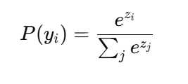

The token with the highest probability is selected during greedy decoding.

**Training Objective (Conceptual)**

BLIP is trained using cross-entropy loss for caption generation:

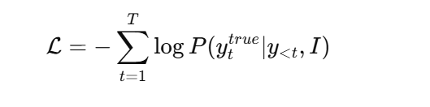

Additional pretraining objectives include:

Image–Text Contrastive Learning (ITC)

Image–Text Matching (ITM)

These objectives improve multimodal understanding.

**Inference in This Application**

**Processing Steps**

1.Uploaded image is converted to RGB format

2.BLIP processor normalizes and tokenizes input

3.Model generates token sequence

4.Tokens are decoded into a caption string

The entire process runs on pretrained weights without fine-tuning.

**FastAPI Integration**

The backend uses FastAPI to expose a REST endpoint:

POST /generate-caption/

Input: Image file

Output: JSON with generated caption

The model is loaded once to avoid repeated initialization overhead.

**Performance Considerations**

1.GPU acceleration significantly improves latency

2.Batch size is set to 1 for real-time inference

3.Model size is optimized for deployment

**Advantages of BLIP**

1.Strong vision–language alignment

2.Pretrained on large-scale image–text data

3.High-quality captions with semantic richness

4.Flexible for multiple multimodal tasks

**Conclusion**

This project demonstrates a complete image captioning pipeline using the BLIP model. By combining Vision Transformers, multimodal attention, and autoregressive text generation, the system produces accurate and descriptive captions from images. The FastAPI-based backend enables easy integration into real-world applications.

18. References

1. Li et al., *BLIP: Bootstrapped Language–Image Pretraining*
2. Vaswani et al., *Attention Is All You Need*
3. Dosovitskiy et al., *An Image is Worth 16×16 Words*
4. Hugging Face Transformers Documentation

### Model 2: Cat vs Dog Image Classification using ImageNet CNNs

**Technical description**

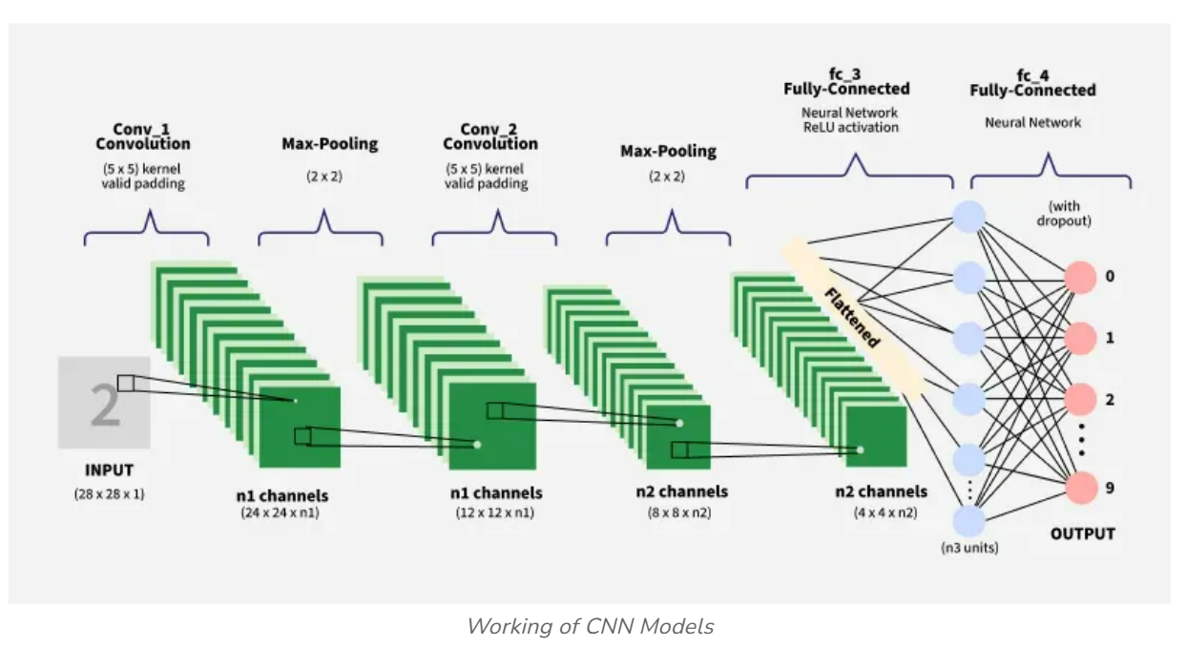

**FIG: WORKING OF CNN MODELS**

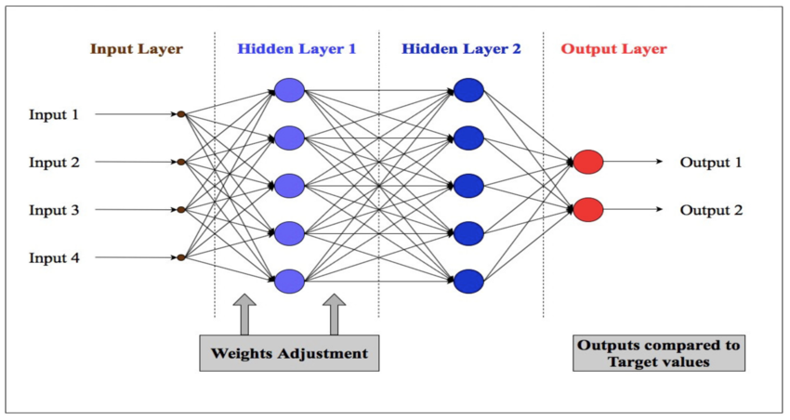

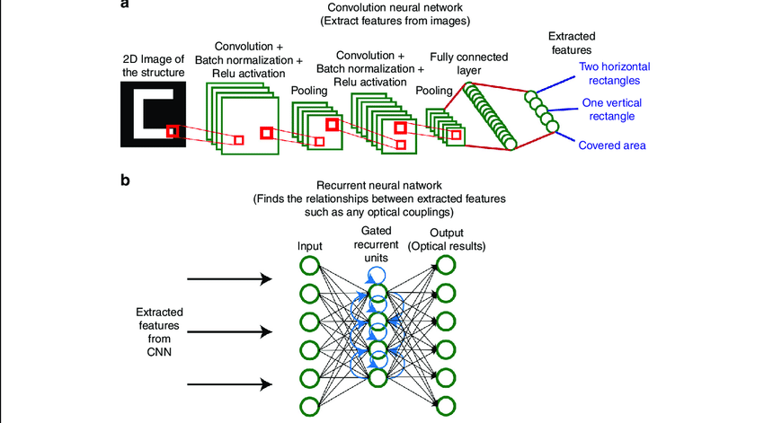

**FIG: IMAGENET ARCHITECTURE**

**Introduction**

Image classification is a core problem in computer vision where the goal is to assign a label to an image based on its visual content. This project focuses on binary image classification, specifically distinguishing between cats and dogs, using deep learning and transfer learning techniques.

Instead of training a convolutional neural network (CNN) from scratch, this project leverages ImageNet-pretrained models to improve performance, reduce training time, and handle limited data efficiently.

**Dataset Description**

The dataset consists of labeled images of cats and dogs organized in a directory structure compatible with Keras:

Dataset/

├── train/

│ ├── cats/

│ └── dogs/

├── validation/

│ ├── cats/

│ └── dogs/

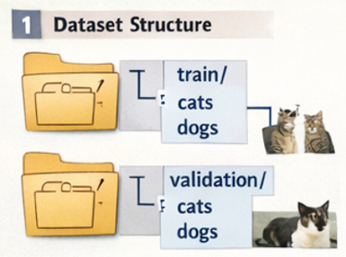

**Key Properties**

RGB images

Varying resolutions

Binary labels (Cat = 0, Dog = 1)

This folder-based organization allows automatic label inference by Keras data loaders.

**Data Preprocessing**

**Image Resizing**

All images are resized to **224 × 224 × 3**, which is the required input size for most ImageNet models (e.g., VGG16).

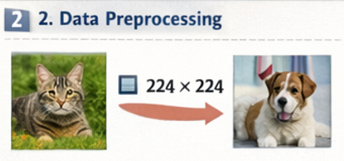

**Normalization**

Pixel values are rescaled from [0, 255] to [0, 1]:

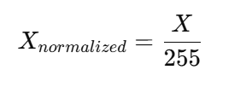

Normalization improves numerical stability and accelerates gradient-based optimization.

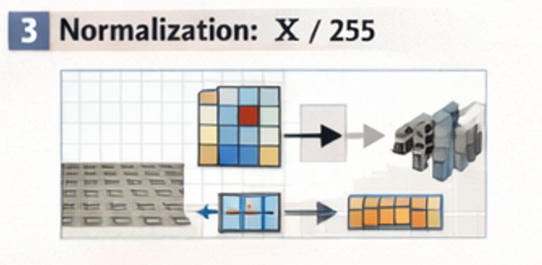

**Data Augmentation**

To reduce overfitting and improve generalization, data augmentation is applied to training images.

**Augmentation Techniques**

| **Technique** | **Mathematical Effect** |
| --- | --- |
| Rotation | ( R(theta)X ) |
| Zoom | ( sX ) |
| Horizontal Flip | ( X' = X[:, ::-1] ) |
| Rescaling | ( X / 255 ) |

These transformations create new training samples without increasing dataset size.

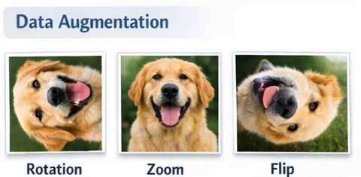

**Convolutional Neural Networks (CNNs)**

CNNs are specialized neural networks designed for image data. They exploit local spatial correlations and parameter sharing.

**Convolution Operation**

A convolution layer computes:

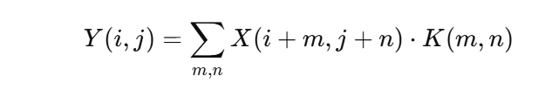

Where:

(X) = Input image

(K) = Kernel (filter)

(Y) = Feature map

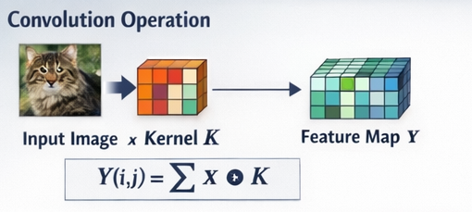

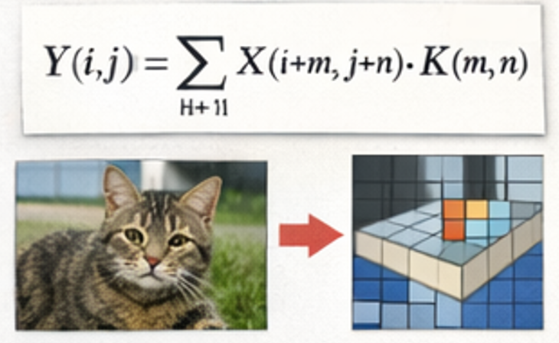

**Pooling**

Max-pooling reduces spatial dimensions:

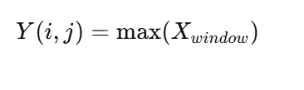

This provides translation invariance and reduces computation.

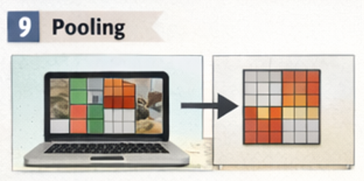

**Transfer Learning**

**Concept**

Transfer learning reuses knowledge from a model trained on a large dataset (ImageNet) and applies it to a new task.

ImageNet contains 14+ million images across 1000 classes, enabling models to learn universal visual features such as edges, textures, and shapes.

**Feature Extraction**

Pretrained convolutional layers are frozen and used as fixed feature extractors:

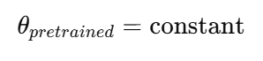

Only newly added layers are trained.

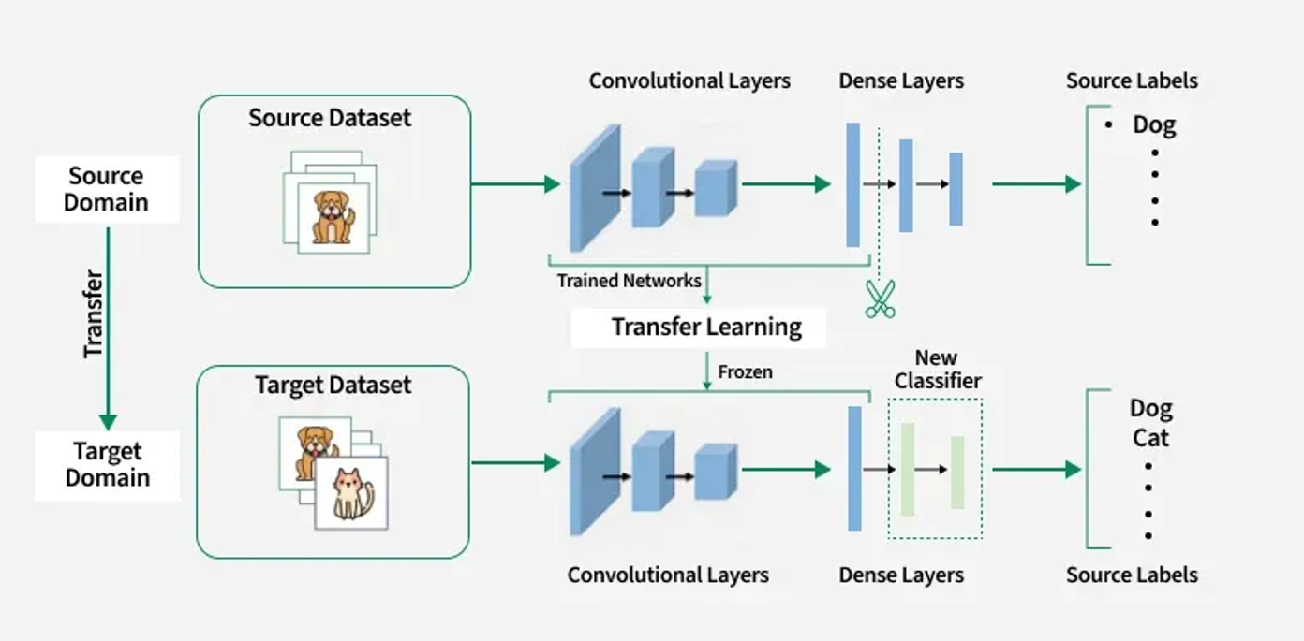

**FIG: TRANSFER LEARNING ARCHITECTURE**

**Model Architecture**

**Base Model (VGG16)**

VGG16 consists of stacked convolution blocks:

[Conv → ReLU → Conv → ReLU → MaxPool] × N

These layers capture increasingly abstract visual features.

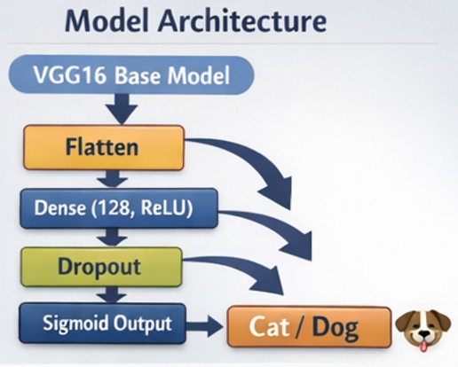

**Custom Classification Head**

Flatten

↓

Dense (128, ReLU)

↓

Dropout (0.5)

↓

Dense (1, Sigmoid)

**Layer Functions**

**Flatten**: Converts 3D feature maps to 1D vector

**Dense**: Learns task-specific patterns

**Dropout**: Prevents overfitting

**Sigmoid**: Outputs probability

**Mathematical Formulation of the Model**

**Dense Layer**

Z=W^TX+b

**Activation Functions**

**ReLU:**  
  
f(x)=max(0,x)

**Sigmoid:**  
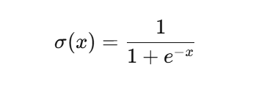

**Loss Function**

Binary Cross-Entropy is used:

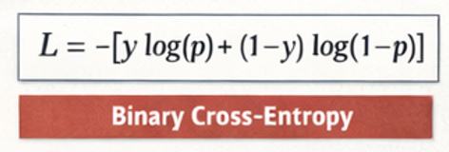

Where:

(y) = True label

(p) = Predicted probability

This loss penalizes confident wrong predictions heavily.

**Optimization**

**Adam Optimizer**

Adam combines momentum and adaptive learning rates:

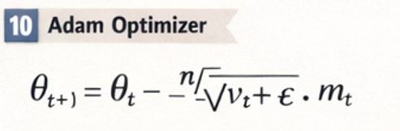

Where:

(m\_t) = First moment estimate

(v\_t) = Second moment estimate

Adam provides fast convergence and robustness.

**Training Process**

For each epoch:

1.Load batch of images

2.Forward propagation

3.Loss computation

4.Backpropagation

5.Weight update

Frozen layers remain unchanged; only custom layers are updated.

**Model Evaluation**

Performance is measured using:

Training Accuracy

Validation Accuracy

Loss Curves

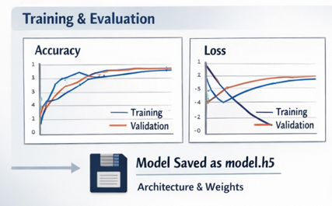

**Overfitting Detection**

If validation loss increases while training loss decreases, overfitting is occurring.

**Prediction Pipeline**

Input Image

→ Resize (224×224)

→ Normalize

→ CNN Feature Extraction

→ Dense Layers

→ Sigmoid Output

→ Cat / Dog

A threshold of 0.5 is used for binary decision making.

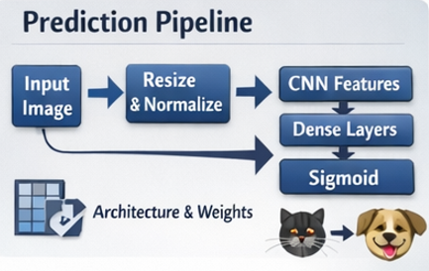

**Model Persistence**

The trained model is saved in .h5 format, which stores:

Model architecture

Weights

Optimizer state

This allows reuse without retraining.

**Conclusion**

This model demonstrates a complete, production-ready deep learning pipeline for image classification using:

Transfer learning

CNN architectures

Mathematical optimization

Regularization techniques

By leveraging ImageNet pretrained models, high accuracy is achieved with limited data and reduced computational cost.

References

1. Krizhevsky et al., *ImageNet Classification with Deep CNNs*
2. Simonyan & Zisserman, *Very Deep CNNs (VGG)*
3. Goodfellow et al., *Deep Learning*

## Module 2:

### Model 1: Text-to-Image Generation using STABLE DIFFUSION Deep Learning

**Technical DESCRIPTION**

**Introduction**

Text-to-Image (TTI) generation is a cutting-edge task in **multimodal artificial intelligence** where a model generates realistic images from natural language descriptions. This module implements a **backend system for text-to-image generation**, integrating deep learning models, API-based inference, and image post-processing.

This module is done in notebook and it focuses on building a **server-side (backend) pipeline** capable of receiving text prompts, generating images using pretrained diffusion-based or transformer-based models, and returning the generated images programmatically.

**Problem Statement**

Given a natural language prompt such as:

"A futuristic city at sunset with flying cars"

The system should generate a visually coherent image that semantically aligns with the prompt.

This requires understanding:

1.Natural Language Processing (NLP)

2.Vision-language alignment

3.Probabilistic generative modeling

**System Architecture Overview**

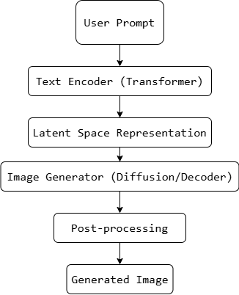

**FIG: System Architecture**

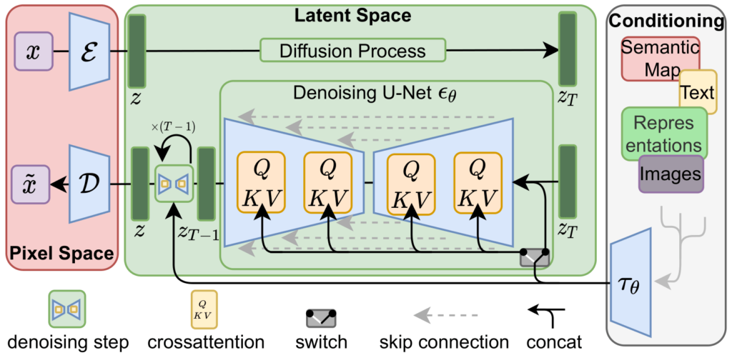

**FIG: STABLE DIFFUSION MODEL ARCHITECTURE**

**Environment Setup and Dependencies**

**Libraries Used**

1.Python

2.PyTorch / TensorFlow

3.Hugging Face Transformers

4.Diffusers

5.PIL (Python Imaging Library)

6.FastAPI / Backend utilities (where applicable)

These libraries enable model loading, tensor computation, and image handling.

**Text Input Processing**

**Tokenization**

Text prompts are converted into numerical tokens using a tokenizer:

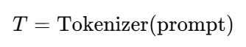

Tokenization converts raw text into discrete IDs that can be processed by transformer models.

**Text Encoder (Transformer Model)**

**Transformer Architecture**

Transformers use **self-attention** to capture contextual meaning:

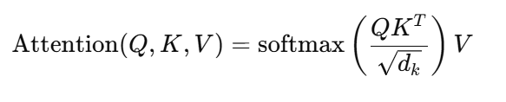

Where:

Q = Query

K = Key

V = Value

The output embedding represents the semantic meaning of the text prompt.

**Latent Space Representation**

Instead of generating images directly in pixel space, modern TTI systems operate in a **compressed latent space**.

**Benefits**

1.Faster computation

2.Lower memory usage

3.Better image quality

Mathematically:

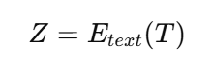

Where (Z) is a latent embedding conditioned on text.

**Image Generation Model**

**Diffusion Models (Conceptual)**

Diffusion models learn to reverse a gradual noising process:

Forward Process:

#### 

Reverse Process:

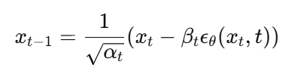

Where:

(x\_0) = original image

(epsilon) = Gaussian noise

The model iteratively denoises latent vectors into images.

**Conditioning on Text**

The generation process is **conditioned** on text embeddings:

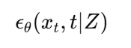

This ensures generated images align with the textual description.

**Sampling Strategy**

Common sampling strategies include:

DDPM

DDIM

PLMS

Sampling trades off between:

Speed

Image fidelity

**Image Decoding**

The final latent output is decoded into pixel space using a decoder network:

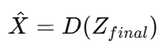

Where:

(D) = Decoder

(\hat{X}) = Generated image

**Post-processing**

Post-processing includes:

1.Clipping pixel values

2.Converting tensors to images

3.Resizing

4.Format conversion (PNG/JPEG)

This makes the output usable for downstream applications.

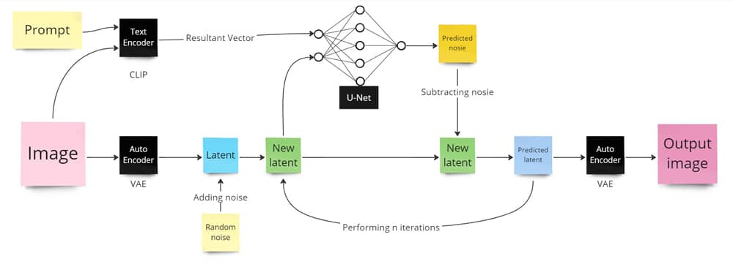

**FIG: UNET ARCHITECTURE**

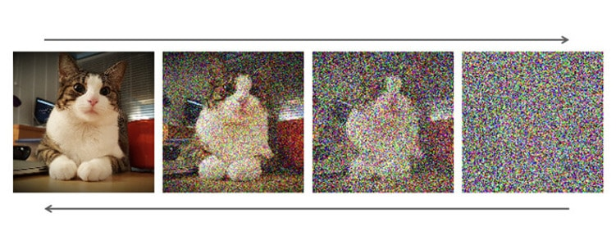

**FIG: NOISING AND DENOISING PROCESS**

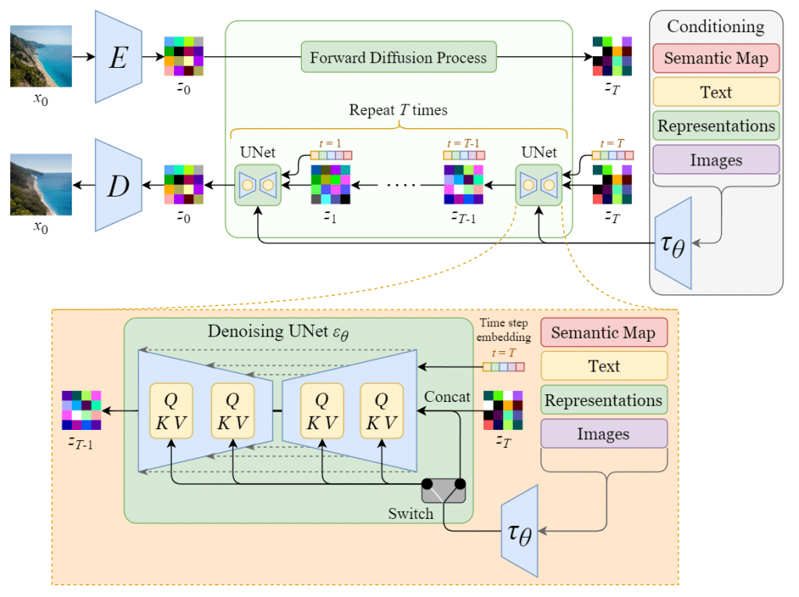

**FIG: MODEL ARCHITECTURE**

**Conclusion**

This project model demonstrates a complete backend pipeline for text-to-image generation using modern deep learning models. By combining transformers, latent diffusion models, and efficient backend design, the system enables scalable and high-quality image generation from natural language prompts.

**20. References**

1. Rombach et al., High-Resolution Image Synthesis with Latent Diffusion Models
2. Vaswani et al., Attention Is All You Need
3. OpenAI, DALL·E
4. Hugging Face Diffusers Documentation

### Model 2: Butterfly Image Generation using Diffusion Models (DDPM)

**Technical description**

**Introduction**

Image generation is a fundamental problem in generative modeling, where the objective is to learn the underlying data distribution and generate new, realistic images. Unlike image classification, generative tasks do not predict labels; instead, they synthesize data.

This project focuses on training and deploying a diffusion-based generative model to generate butterfly images, using Denoising Diffusion Probabilistic Models (DDPMs) implemented via the Hugging Face Diffusers library.

The work combines:

1.Model training and fine-tuning using Diffusers and Accelerate

2.Model inference and deployment using FastAPI and ngrok

The final system enables on-demand butterfly image generation via an API.

**Dataset Description**

The dataset consists of butterfly images, used to train a generative model that learns the visual distribution of butterflies.

**Dataset Characteristics**

RGB images

Natural variations in:

Wing shapes

Color patterns

Textures

Backgrounds

Unlabeled (unsupervised learning)

Unlike classification datasets, no class labels are required. The model learns directly from pixel distributions.

**Diffusion Models Overview**

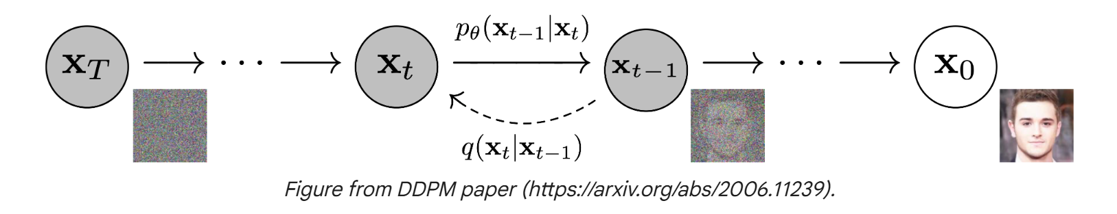

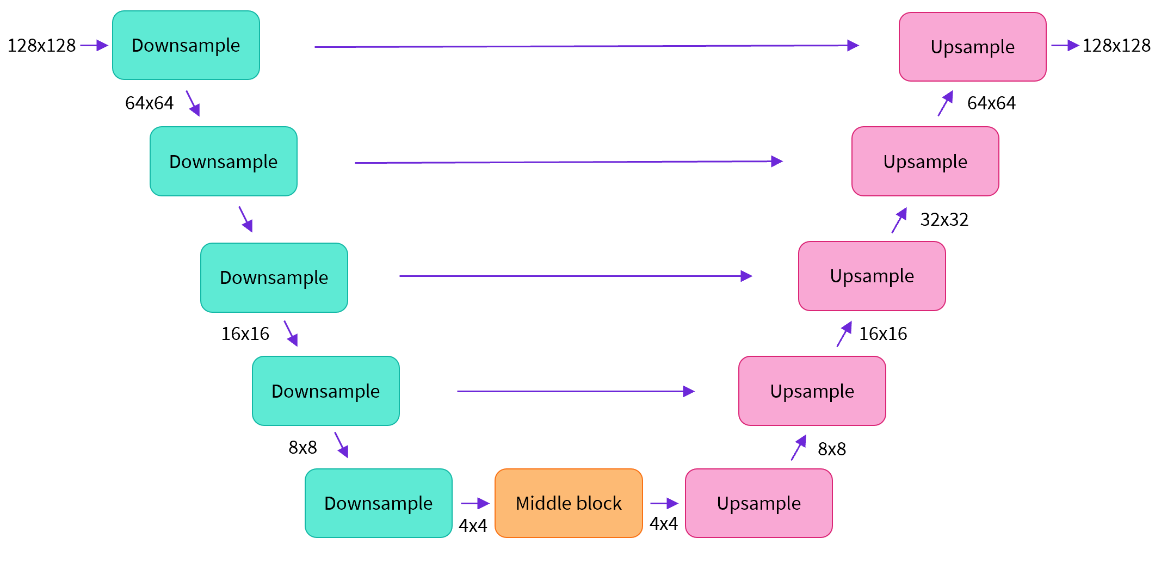

**FIG: DIFFUSION MODEL**

**Generative Modeling Paradigm**

Diffusion models generate images by learning to reverse a gradual noising process. Instead of generating images in a single step, they refine noise over many steps.

**Mathematical Foundation of Diffusion Models**

**Forward Diffusion Process**

Noise is gradually added to an image over T timesteps:

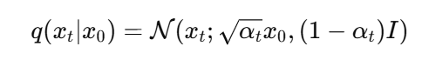

Where:

x0x\_0x0​: Original image

xtx\_txt​: Noisy image at timestep ttt

αt\alpha\_tαt​: Noise schedule

As t→Tt \to Tt→T, the image approaches pure Gaussian noise.

**Reverse Denoising Process**

The model learns the reverse process:

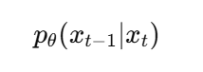

This is done by predicting the noise component added at each timestep.



**Model Architecture**

**Denoising Network (U-Net)**

The core neural network is a U-Net architecture, which consists of:

Downsampling Path → Bottleneck → Upsampling Path

Key properties:

1.Skip connections preserve spatial details

2.Time embeddings condition the network on diffusion step

3.Convolutions learn hierarchical visual features

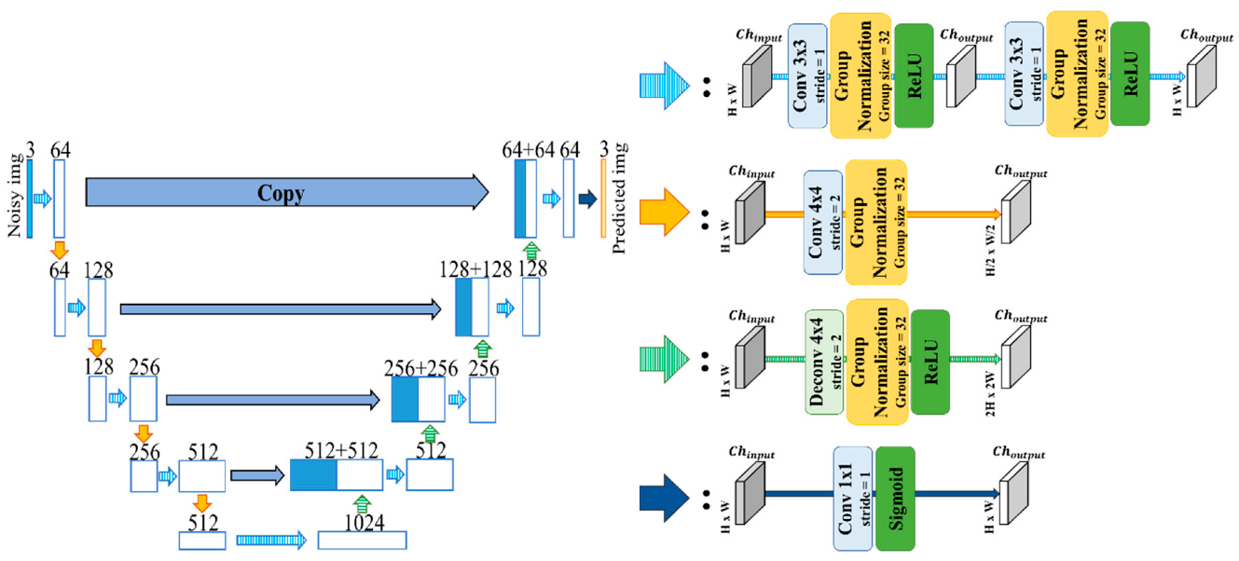

**FIG: U-NET ARCHITECTURE**

**Parameterization**

The model predicts noise ϵθ(xt,t)\epsilon\_\theta(x\_t, t)ϵθ​(xt​,t) rather than the clean image directly, improving training stability.

**Loss Function**

The training objective minimizes Mean Squared Error (MSE) between true noise and predicted noise:

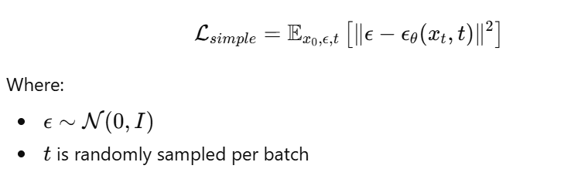

**Training Pipeline**

**Frameworks and Libraries**

1.Diffusers

2.Accelerate

3.PyTorch

4.TorchVision

**Training Configuration**

Key training parameters include:

1.Batch size

2.Image resolution

3.Learning rate

4.Number of diffusion steps

5.Mixed precision (fp16)

Accelerate enables multi-GPU and mixed-precision training for efficiency.

**Training Loop**

For each iteration:

1.Sample image x0x\_0x0​

2.Add noise → obtain xtx\_txt​

3.Predict noise ϵθ\epsilon\_\thetaϵθ​

4.Compute MSE loss

5.Backpropagation

6.Optimizer step

**Model Checkpointing and Versioning**

The trained model is:

1.Saved as Diffusers pipeline

2.Uploaded to Hugging Face Hub

3.Version-controlled using Git-LFS

This enables:

1.Reproducibility

2.Public or private sharing

3.Easy loading for inference

**Image Generation (Inference)**

**Sampling Process**

Image generation starts from pure noise:



The model iteratively denoises:



Resulting in high-quality butterfly images.

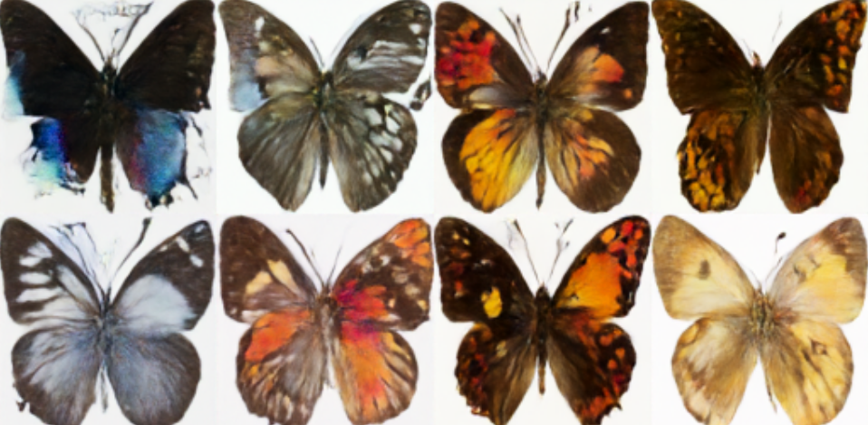

**Pipeline Usage**

pipe = DDPMPipeline.from\_pretrained(MODEL\_ID)

images = pipe(batch\_size=N).images

Generated images are converted to PIL format for visualization or API delivery.

**Deployment Architecture**

**FastAPI Backend**

The trained model is deployed using **FastAPI**, providing:

1.REST API endpoint

2.JSON-based image requests

3.Base64-encoded image responses

**API Workflow**

Client Request

→ FastAPI Endpoint

→ Diffusion Pipeline

→ Image Generation

→ Base64 Encoding

→ JSON Response

**Performance Considerations**

1.GPU acceleration (cuda)

2.FP16 inference reduces memory usage

3.Batch inference supported

**Conclusion**

This project demonstrates an end-to-end generative AI system for butterfly image generation using diffusion models:

Mathematical rigor via DDPM formulation

Scalable training with Accelerate

High-quality image synthesis

Production-ready deployment using FastAPI

The system successfully transforms random noise into realistic butterfly images, showcasing the power of modern diffusion-based generative modeling.

**References**

1. Ho et al., *Denoising Diffusion Probabilistic Models*
2. Hugging Face, *Diffusers Documentation*
3. Goodfellow et al., *Deep Learning*
4. PyTorch Documentation

## Module 3: AI News Generation System using LLM Agents, Web Tools, TTS, and Video Synthesis

**Technical DESCRIPTION**

**Introduction**

This module implements an AI-powered news generation system that autonomously produces news content using Large Language Models (LLMs), enriches it with real-time web information, and optionally converts the news into audio and video media suitable for social platforms.

The system is built using:

1.Agent-based LLM orchestration (Agno)

2.Web search tools (DuckDuckGo)

3.FastAPI backend

4.Text-to-Speech (gTTS)

5.Video synthesis (MoviePy)

The result is a full multimodal AI news pipeline.

**High-Level System Architecture**

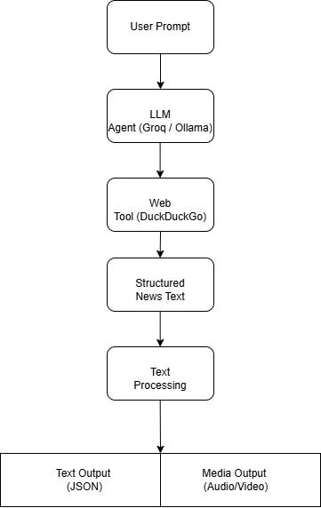

**FIG: System Architecture**

**Agent-Based Design**

What is an Agent?

An LLM agent is an autonomous entity that:

1.Receives a goal (prompt)

2.Decides whether to use tools

3.Gathers external information

4.Produces a final response

In this system, the agent behaves as a news reporter, combining language generation with real-time search.

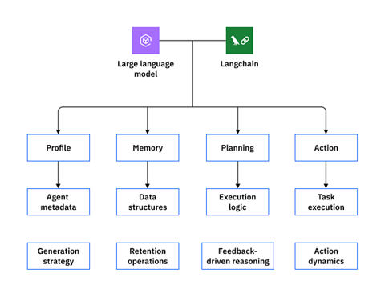

**FIG: Agent-based LLM orchestration (Agno)**

**LLM Model Selection**

Groq-hosted Model

model = Groq(id="openai/gpt-oss-120b")

1.120B parameter open-source-grade model

2.High reasoning and summarization ability

3.Optimized inference via Groq hardware

**Alternative Local Model (Ollama)**

Ollama(id="deepseek-r1:1.5b")

Allows offline or low-resource inference.

**Tool Integration (Web Search)**

**DuckDuckGoTools**

The agent is equipped with a search tool:

tools=[DuckDuckGoTools()]

This enables:

Real-time news retrieval

Fact grounding

Reduced hallucination

The agent dynamically decides when to call the tool.

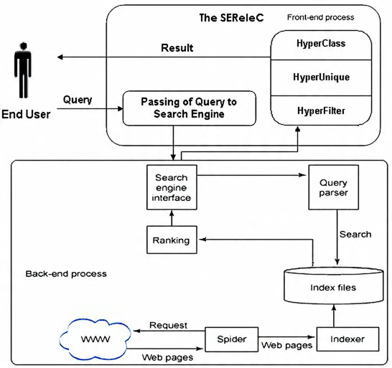

**FIG: DUCKDUCKGO WEB SEARCH**

**Agent Configuration Parameters**

| **Parameter** | **Purpose** |
| --- | --- |
| description | Defines agent persona |
| tools | Enables external actions |
| parse\_response | Structured parsing |
| structured\_outputs | JSON-like outputs |
| markdown | Readable formatting |

These parameters control behavior, reliability, and output quality.

**Prompt-to-News Generation Flow**

**Mathematical Abstraction**

The agent computes:

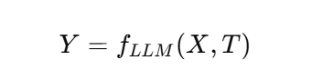

Where:

(X) = user prompt

(T) = external tool results

(Y) = generated news content

The model performs conditional text generation:

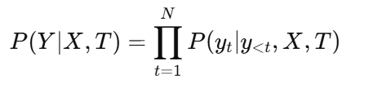

**FastAPI Integration**

**API Endpoint: Generate News**

POST /api/generate-news

Input: prompt

Output: structured news text

The API acts as a stateless interface over a stateful agent instance.

**News Text Post-Processing**

**Emoji Removal**

Regular expressions remove emojis to ensure:

TTS compatibility

Professional tone

**Markdown & Noise Cleaning**

Markdown symbols and timestamps are stripped for clean narration.

**News Structuring Logic**

The generated text is parsed into:

Headline

Bullet points

Speech-friendly paragraph

This enables reuse across text, audio, and video modalities.

**Text-to-Speech (TTS)**

**gTTS Engine**

Text is converted into speech:

Audio=TTS(Text)

Uses Google neural voices

Outputs MP3 format

Language-agnostic support

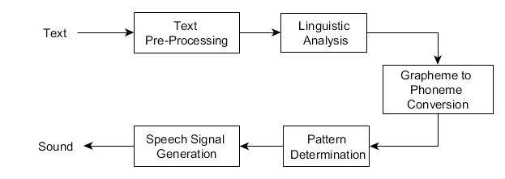

**FIG: gTTS ARCHITECTURE**

**Audio–Video Synchronization**

**Video Looping Strategy**

Given:

Video duration = (D\_v)

Audio duration = (D\_a)

Required loops:

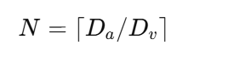

The anchor video is looped to match narration length.

**Video Composition**

Using MoviePy:

Loop video

Trim excess

Attach audio

Encode with H.264 + AAC

This produces a broadcast-ready news video.

**Media API Endpoint**

POST /api/news-with-media

**Response Includes**

Headline

Bullet points

Audio URL

Video URL

This endpoint enables end-to-end AI news generation.

File System Design

**media/**

├── audio/

│ └── uuid.mp3

└── video/

└── uuid.mp4

UUIDs ensure collision-free, scalable storage.

**Scalability Considerations**

1.Agent loaded once in memory

2.Stateless HTTP requests

3.Media generation offloaded to disk

4.GPU optional for LLM inference

**Advantages**

1.Real-time news grounding

2.Multimodal output

3.Modular agent design

4.Easy model swapping

**Conclusion**

This module demonstrates a state-of-the-art AI news generation pipeline combining LLM agents, real-time web tools, and multimodal media synthesis. It reflects modern AI system design principles and is suitable for real-world deployment in digital journalism, content automation, and media platforms.

**22. References**

1. ReAct: Synergizing Reasoning and Acting in LLMs
2. DuckDuckGo Instant Answer API
3. Groq LPU Architecture
4. MoviePy Documentation
5. gTTS Documentation

## Module 4: NexusGPT: Enterprise-Grade Conversational AI System using LangChain and Ollama

**Technical DESCRIPTION**

**Introduction**

This module implements **NexusGPT**, an enterprise-grade conversational AI system designed for professional, structured, and documentation-quality responses. The system integrates:

**LangChain** for prompt orchestration

**Ollama** for local Large Language Model (LLM) inference

**FastAPI** for backend API exposure

**HTML, JavaScript, and Web Speech API** for frontend interaction

The primary objective is to deliver a **production-ready AI chat interface** with strict response formatting, multimodal input support, and clean UI integration.

**High-Level System Architecture**

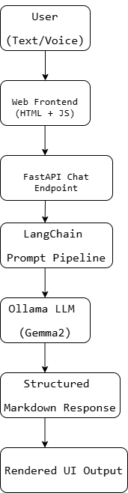

**FIG: System Architecture**

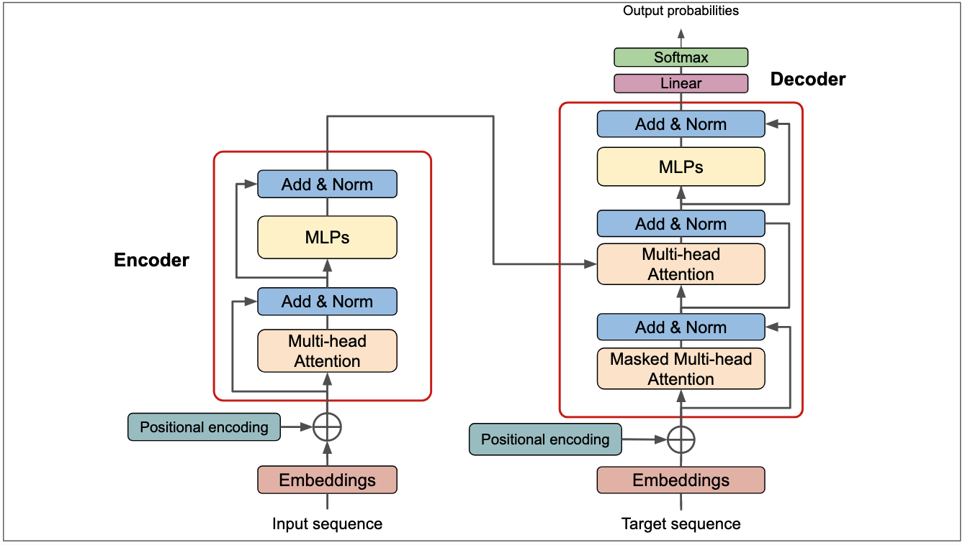

**FIG: TRANSFORMER ARCHITECTURE**

**Environment Configuration**

**LangChain Tracing**

os.environ["LANGCHAIN\_TRACING\_V2"] = "true"

Enables request-level tracing for:

Debugging

Prompt analysis

Performance monitoring

**Project and API Keys**

Environment variables ensure:

Secure credential management

Separation of configuration from code

**Prompt Engineering with ChatPromptTemplate**

**System Prompt Design**

The system prompt defines **strict behavioral constraints**:

Professional tone

Markdown-only responses

Deterministic formatting rules

Separation of code and explanation

This ensures responses resemble **official technical documentation**.

**Prompt–Response Formalization**

The conversation is modeled as:

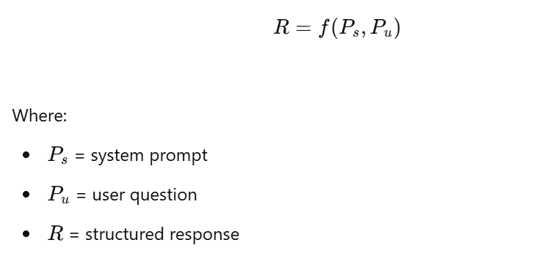

LangChain guarantees consistent prompt injection before each request.

**LLM Selection (Ollama + Gemma2)**

llm = Ollama(model="gemma2:2b")

**Model Characteristics**

2B parameters

Efficient local inference

Low latency

Privacy-preserving (no cloud calls)

This choice balances **performance, cost, and control**.

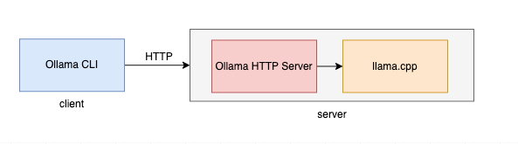

**FIG: OLLAMA ARCHITECTURE**

**LangChain Runnable Pipeline**

chain = prompt | llm | output\_parser

**Pipeline Stages**

Prompt construction

Model inference

Output parsing

This forms a **deterministic, composable execution graph**.

**Output Parsing**

**StrOutputParser**

Ensures:

Clean string output

No metadata leakage

UI-safe rendering

This is critical for frontend Markdown rendering.

**FastAPI Backend Design**

**Chat Endpoint**

POST /api/chat

Request Schema

{

"question": "string"

}

Response Schema

{

"answer": "markdown string"

}

The endpoint is:

Stateless

JSON-based

Easily scalable

**Error Handling**

If the question is missing:

HTTP 400 returned

Clear error message

This enforces API correctness.

**Frontend UI Architecture**

**Navigation Layer**

Branding header

Route-based navigation

User profile placeholder

**Hero Section**

Communicates:

Platform vision

Multimodal AI capabilities

**Chat Interface Design**

**Components**

Textarea input

Send button

Microphone button

Response container

The layout is optimized for **clarity and usability**.

**Markdown Rendering**

marked.parse(data.answer)

The marked library converts Markdown into HTML while preserving:

Code blocks

Headings

Lists

This allows LLM responses to appear as formatted documentation.

**Voice Input Integration**

**Web Speech API**

Speech recognition pipeline:

Microphone → SpeechRecognition → Text → Input Box

Configuration:

Language: en-US

Non-interim results

This enables **hands-free interaction**.

**Multimodal Interaction Model**

The system supports:

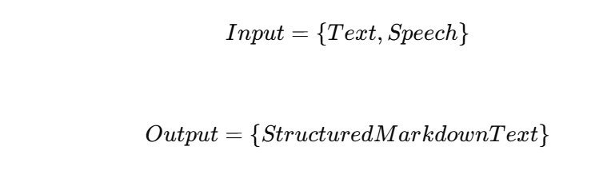

This aligns with modern conversational AI UX standards.

**Security Considerations**

No client-side API keys

Environment-based secrets

Local inference reduces data exposure

**Performance Considerations**

Lightweight 2B model

Prompt caching via LangChain

Minimal frontend JavaScript

This ensures low-latency interactions.

**Advantages of the System**

1.Enterprise-grade response formatting

2.Deterministic prompt behavior

3.Modular architecture

4.Fully offline-capable LLM

**Conclusion**

NexusGPT represents a **professional-grade conversational AI platform** built with modern LLM orchestration principles. By combining LangChain, Ollama, FastAPI, and a structured frontend, the system delivers reliable, well-formatted, and enterprise-ready AI interactions suitable for real-world deployment.

**22. References**

1. LangChain Documentation
2. Ollama Model Runtime
3. Web Speech API Specification
4. FastAPI Documentation
5. Markdown Rendering with Marked.js

## Module 5: Podcast Q&A System using Speech-to-Text, Vector Embeddings, and Large Language Models

**Technical DESCRIPTION**

**Introduction**

This project implements an end-to-end Podcast Question & Answering (Q&A) system that enables users to upload podcast audio, automatically transcribe it, store semantic representations of the transcript, and ask natural language questions grounded strictly in the podcast content.

The system combines:

Speech-to-Text (Whisper)

Audio preprocessing

Sentence embeddings

Vector databases (Pinecone)

Large Language Models (LLMs)

FastAPI backend services

This architecture reflects modern Retrieval-Augmented Generation (RAG) design patterns.

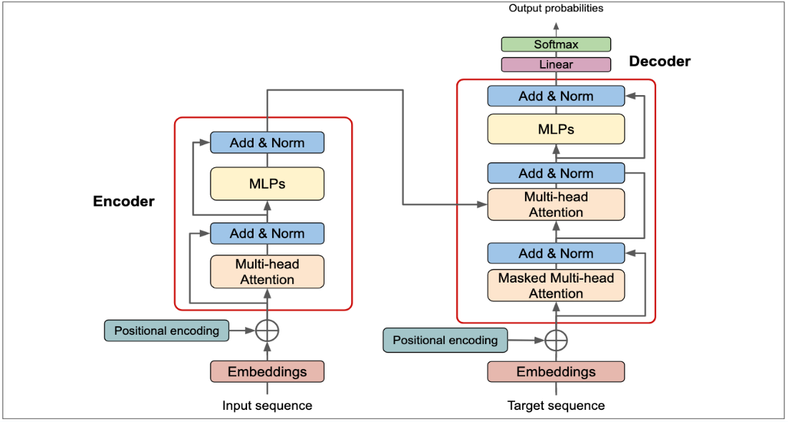

**FIG: TRANSFORMER ARCHITECTURE**

**High-Level System Architecture**

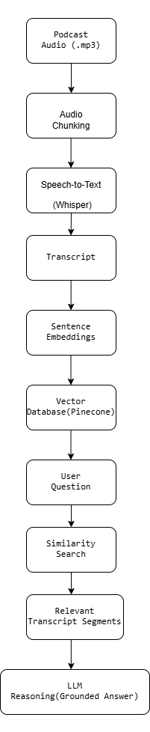

**FIG: SYSTEM ARCHITECTURE**

**Audio Processing Pipeline**

**Audio Chunking**

Long podcast audio files are split into smaller segments to:

Avoid transcription limits

Improve transcription accuracy

Reduce memory usage

Each chunk has a fixed duration (30–60 seconds).

**Mathematical Representation**

Given audio duration (D) and chunk size (c):

N=[D/c]

Where (N) is the number of chunks.

**Speech-to-Text (Whisper)**

**Whisper Model**

The system uses Whisper Large v3, a transformer-based speech recognition model.

Audio signal (A) is mapped to text (T):

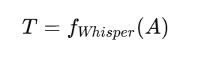

Whisper employs:

Log-mel spectrograms

Encoder–decoder transformers

Multilingual training

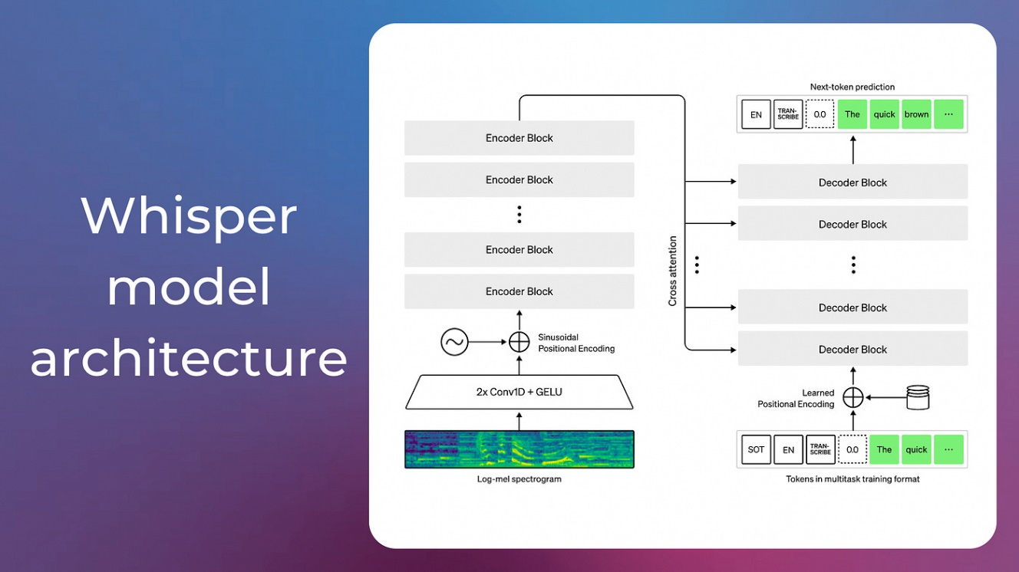

**Transcript Aggregation**

Each transcribed chunk produces partial text:

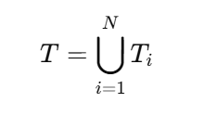

All segments are concatenated into a single coherent transcript.

**Embedding Generation**

**SentenceTransformer Embeddings**

The model all-MiniLM-L6-v2 converts text into dense vectors:

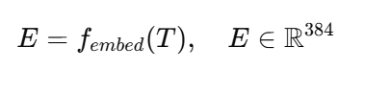

These embeddings preserve semantic meaning and enable similarity search.

**Vector Database (Pinecone)**

**Storage**

Each transcript (or chunk) is stored as a vector in Pinecone.

**Similarity Search**

For a query vector (q):

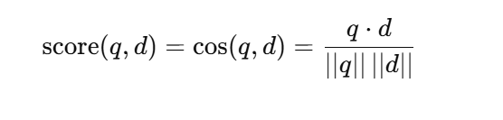

Top-k most similar transcript segments are retrieved.

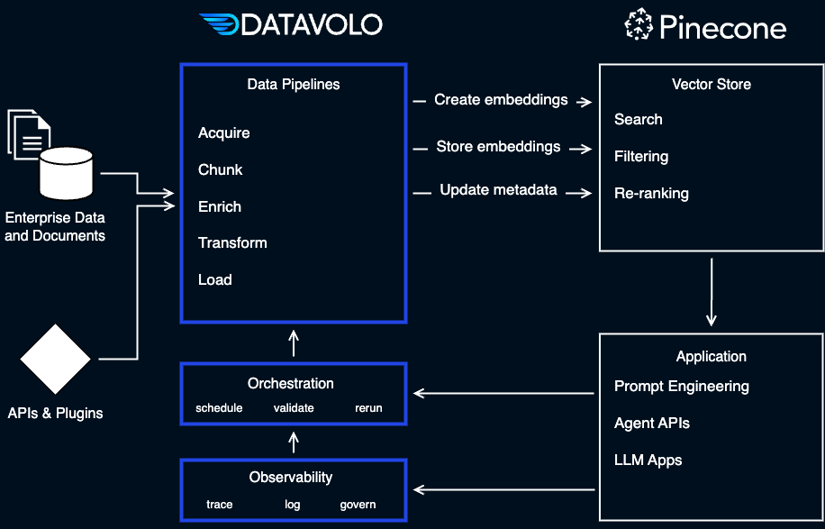

**Fig:  [vector retrieval with Pinecone](https://datavolo.io/vector-retrieval-pinecone/" \t "_blank)**

**Retrieval Augmented Generation (RAG)**

The system follows a RAG paradigm:

Answer=LLM(Question|RetrievedContext)

This ensures answers are:

Grounded

Explainable

Podcast-specific

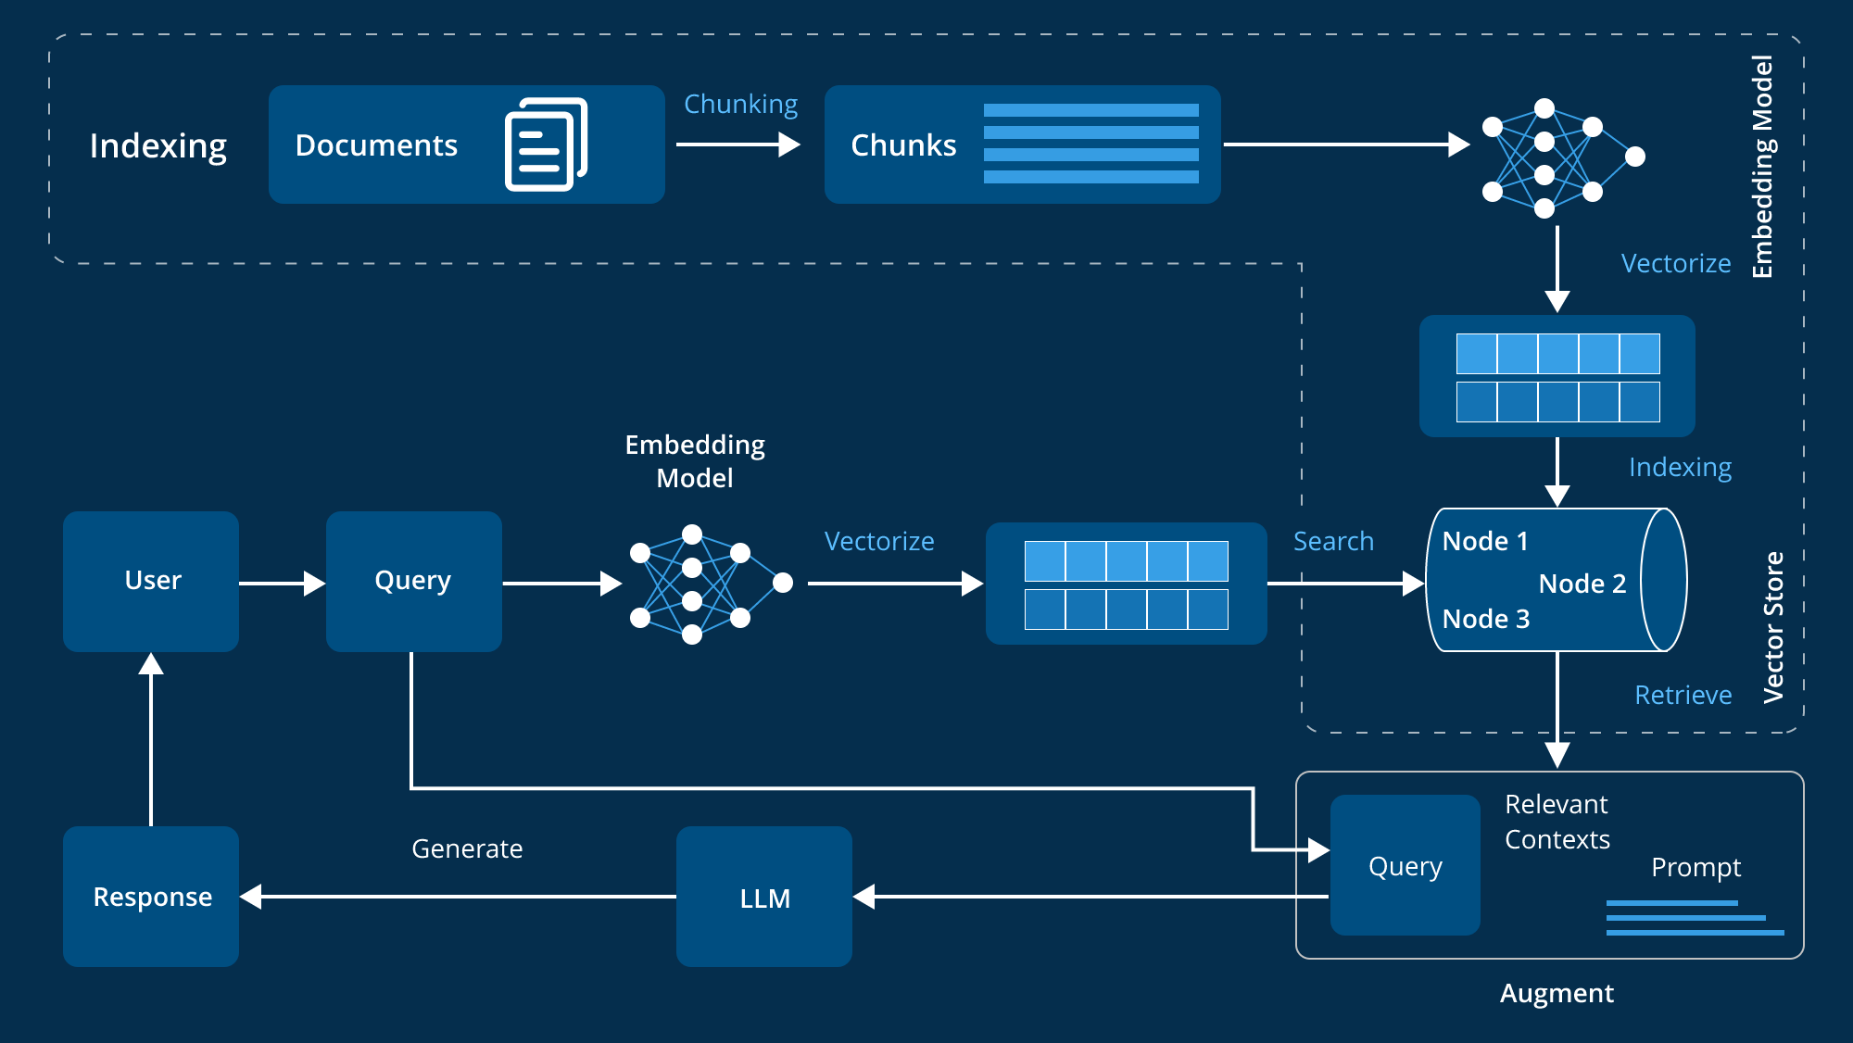

**FIG: Retrieval Augmented Generation (RAG)**

**LLM-Based Question Answering**

**Prompt Conditioning**

The system prompt explicitly constrains the LLM:

Use this transcript to answer the question, citing specific quotes*.*

This minimizes hallucination.

**Autoregressive Generation**

The LLM computes:

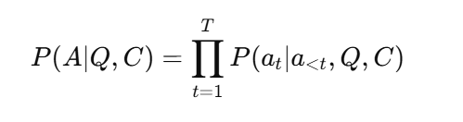

Where:

(Q) = user question

(C) = retrieved transcript context

**Backend API Design**

**Transcription Endpoint**

POST /api/podcast/transcribe

Upload audio

Chunk processing

Whisper transcription

Embedding storage

**Q&A Endpoint**

POST /api/podcast/ask

Accepts user question

Performs similarity search

Generates grounded answer

**Performance Considerations**

Chunked audio processing

Lightweight embedding model

Top-k retrieval

Stateless API design

**Conclusion**

This Podcast Q&A system demonstrates a production-grade Retrieval-Augmented AI pipeline combining speech recognition, semantic embeddings, and large language models. It enables users to interact intelligently with long-form audio content using natural language, making podcasts searchable, explorable, and actionable.

18. References

1. OpenAI Whisper
2. SentenceTransformers
3. Pinecone Vector Database
4. Retrieval-Augmented Generation (Lewis et al.)
5. LLaMA Models